Note 1. You do not have to fit anything in this template just do the emptying of the document in it (Delete this text in the final document of your research)

Note 2. The entire document must be referenced in APA standards.

TITLE OF THE RESEARCH ARTICLE FOR THE JOURNAL E&A (The title of the article should not exceed 20 words)
Title source: Times New Roman 14 points bold Uppercase
Alignment: Centering
Single line spacing

(Here you must write it in Spanish)

First Author's First Name(s) and Surname(s) ¹
Email First Author @
https://orcid.org/0000... 
When sending, leave anonymous, without placing the identifications. During the rounds of peer review, do not fill in this data.

Name(s) and Surname(s) of the second author ²
Email Second Author @
https://orcid.org/0000...
1. Institution first author, City, Country
2. Institution second author, City, Country

From here all the text goes in Times New Roman font and 12 points. Only the names of each element of the structure are bold.

ABSTRACT

Here you must write it in Spanish.
This abstract is the synthesis of the entire topic covered in the article; it must contain a maximum of 250 words; which must be brief, precise and structured. It should include introduction, methods, results, and conclusions.

Keywords:
Here you should place the words that express the main ideas of your research as follows:
Keyword 1, Keyword 2, Keyword 3 (up to 5 keywords maximum)

Código JEL (Journal of Economic Literature):

TITLE OF THE RESEARCH ARTICLE FOR THE E&A JOURNAL (The title of the article should not exceed 20 words)
(Here you must write it in English)

First Author's First Name(s) and Surname(s) ¹
Email First Author @
https://orcid.org/0000...
When sending, leave anonymous, without placing the identifications. During the rounds of peer review, do not fill in this data.

Name(s) and Surname(s) of the second author ²
Email Second Author @
https://orcid.org/0000...
1. Institution first author, City, Country
2. Institution second author, City, Country

From here all the text goes in Times New Roman font and 12 points. Only the names of each element of the structure are bold.

ABSTRACT
Here you must write it in English.
This abstract is the synthesis of the entire topic covered in the article; it must contain a maximum of 250 words; which must be brief, precise and structured. It should include introduction, methods, results, and conclusions.

Key words:
Here you should place the words that express the main ideas of your research as follows:
Keyword 1, Keyword 2, Keyword 3 (up to 5 keywords maximum)

Código JEL (Journal of Economic Literature):

INTRODUCTION (Title level 2 Times New Roman, bold, capital letters, size 12)
It is the entrance pass to the context of our topic to be discussed. The objectives of the research must be placed within the introduction. It should be concise, generally representing between 10% and 15% of the total manuscript. It usually lasts 1 to 2 pages or 4 to 5 paragraphs. Its objective is to contextualize the topic, justify the research and define the problem, ending with the objectives

CONCEPTUAL FRAMEWORK (Title level 2 Times New Roman, bold, capital letters, size 12)
The theoretical section should be extended, not repeated. The background of the article already discussed in the Introduction and lay the foundations for future work.
It is the essence of your research referenced by existing theories on which you based your analysis. Here we must clearly explain what the problem was that led him to want to look deeper and carry out scientific research.

It is important that in one of the sections you indicate the objective or objectives of your article.

Textual quotations of more than 40 words are in a separate paragraph with a left indentation of 1.25 cm, with single line spacing, without space before or after.

METHODOLOGY (Title level 2 Times New Roman, bold, capital letters, size 12)
This section should disclose the methodology/model used for such research. This includes the sample used, the variables, the context, and everything about how you conducted your research.
In E&A, the types of visual elements that are considered part of the manuscript and are continuously inserted into the text can be: tables and graphs (whether line, bar, circular, scatter, or column, among other types). Likewise, other visual elements are considered as figures: illustrations, infographics, photographs, flowcharts, drawings, maps, among others. All of these types of elements (tables, charts, and figures) have the same general settings. All will be conveniently inserted into the text. Charts and figures, such as images and tables, are preferably created and inserted with the Word tool. Adjust its size so that unwanted empty spaces do not occur. Maximum 7 visual elements in total, be they tables, graphs and/or figures throughout the document.
These visual elements should ideally be inserted after being referred. That is, first the comment is made referring to the image by its number and then the figure is added to the text. Refer to them in the text as follows: Table x, y/or Figure x, and/or Graph x where x is the correlative number of the table, graph or figure. They will consist of an explanatory footnote or Note according to the APA Standards 7 edition.

Description of Using Tables and Figures

Tables and figures must be integrated into the text in the appropriate place. They must be numbered sequentially.
The title of the table or figure will be located at the top of the table. Table 1; Table 2... Figure 1; Figure 2...
The number of the table/figure will follow the following guidelines: Times New Roman font at 12 points, bold and aligned to the left.
The name of the table/figure will be on the following line: Times New Roman font at 12 points, italicized and aligned to the left.

Table 1. Table Title
(Times New Roman 12; Color: white; Blue background, emphasis 5, dark 50%-RGB 121; Front and back spacing 2 cm)
Subtitles (Times New Roman 10; Bold; Auto black type color; Blue background, emphasis 5, clear 80%(RGB-246)
Structure and divide the table according to needs and data. All of its elements will go on Times New Roman 10; Automatic black color aligning the values of the variables per row to the left and centering the values of the variables per column. The values taken by the variables, by cells, will be centered. The edges will be 1/2 point in size. Line spacing in the table is simple, with no spaces before or after.
Source: Own elaboration
Note: "Notes" at the end of the table are supported in this format: Times New Roman 12.

When using tables, they should be placed centered, with Times New Roman font. They will be embedded after they are cited or mentioned for the first time. The tables should be numbered and their headings as shown in the examples in Table 1 and Table 2.

Table 2. Percentage of normative responses
Three institutions and four careers
 | A | B | C
Item 1 | 12 | 35 | 15
Item 2 | 4 | 9 | 17
Item 5 | 3 | 9 | 20
Item 4 | 11 | 4 | 2
Total | 30 | 57 | 54
Source: Own elaboration
Note: "Notes" at the end of the table are supported in this format: Times New Roman 12.

Tables that exceed more than half a page are not allowed. In this case, it is recommended to incorporate the information by means of an external link (DOI) generated in Figshare (https://figshare.com/)

The images will be in JPG format in high resolution (300 dpi), in color. The figures must be provided separately and complementary to the article when it is submitted for evaluation. In the case of graphs, the original data must be sent in Excel.
All the figures used will have a fixed thickness of a maximum of 10 centimeters and in exceptional cases the size can be increased, always adjusting to a fixed thickness.

Figure 1
Higher Education System
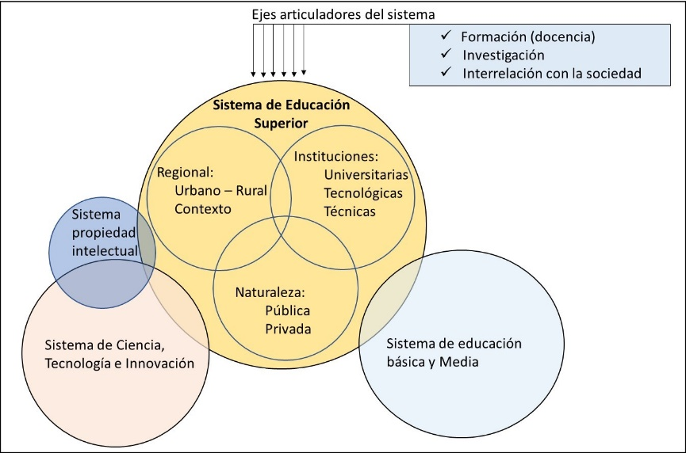
Source: Reference must be made to the authorship of the image. Explain whether it is of their own elaboration, adapted or reproduced from another author. In the latter case, it must be referenced (for example: Adapted from Image Title, Image Author, year of publication of the image, Source. Type of license) and make sure to include an entry in the list of bibliographic references
Note: Add any content you need to describe that can't be understood by the title or image itself alone, such as definitions of abbreviations and extra explanations. Provide copyright credits. Include figure notes if strictly necessary. (Times New Roman 12).
In this space, you will need to insert all the data sources that you have used for your work. These may be bases provided by some institutions or publicly accessible bases that you consulted for support.

DISCUSSION OF RESULTS (Title level 2 Times New Roman, bold, capital letters, size 12)

Here you must place the results obtained in the research put into practice the methodology / model already exposed.
Detail the results of your work. Graphs are handled in the same way as figures.

Figure 1. Number of Higher Education (HE) students in the world and in LAC / in millions (2012-2017)
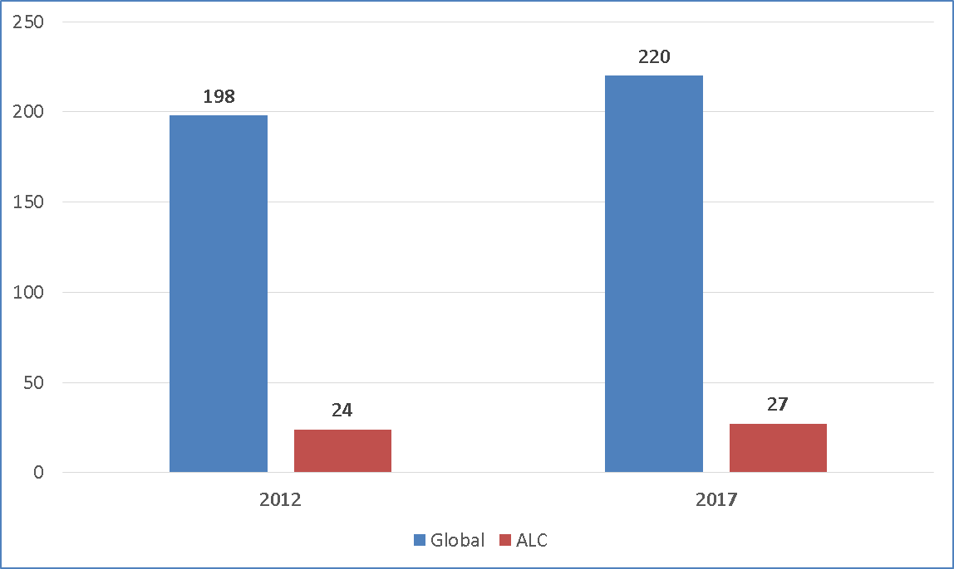
Source: Reference must be made to the authorship of the image. Explain whether it is of your own elaboration, adapted or reproduced from another source. In the latter case, it must be referenced (for example: Adapted from Image Title, Image Author, year of publication of the image, Source. Type of license) and make sure to include an entry in the list of bibliographic references.
Note: Add any content you need to describe that can't be understood by the title or image itself alone, such as definitions of abbreviations and extra explanations. Provide copyright credits. Include figure notes only if strictly necessary.

You can continue explanations of the previous chart and introduce new arguments. That is, maintaining the written development of the manuscript.

CONCLUSIONS (Title level 2 Times New Roman, bold, capital letters, size 12)
The main conclusions of the research should be presented in a condensed section in this space.

Your article should be between 15 and 20 pages maximum
FUNDING (Title level 2 Times New Roman, bold, capital letters, size 12)
Recognize the monetary support of organizations or individuals in the development of the study. If authors do not have to report financial support, they should write "None."
CONFLICTS OF INTEREST (Times New Roman level 2 title, bold, capital letters, size 12)
Any conflicts of interest that may be interpreted as influencing the results of the study should be indicated. If authors do not have to report any conflicts of interest, they should write the word "None."
ETHICAL APPROVAL (Title level 2 Times New Roman, bold, capital letters, size 12)
In this section, you should acknowledge whether people have given permission to use your data or report that this manuscript does not need ethical approval by typing the word "Exempt."
USE OF AI (Title level 2 Times New Roman, bold, uppercase, size 12)
Examples: AI tools were used too (declare the use they were given). Failing that, write "Not used".

DATA AVAILABILITY (Title level 2 Times New Roman, bold, capital letters, size 12)

Authors should indicate whether data supporting study results are publicly available, can be requested from the corresponding author, or are restricted for ethical or legal reasons.

REFERENCES (Title level 2 Times New Roman, bold, capital letters, size 12)

They must be placed in accordance with APA regulations. In addition, they must be in alphabetical order, and the minimum number of citations will be 30 references.

Jung Hanns, R., 2000. "The right to information in Germany" in Villanueva, E. (coord.) Towards a new right to information. First National Congress on the Right to Information, November 9, 10 and 11, 2000, Mexico, Universidad Iberoamericana / Alianza Editorial / Konrad Adenauer Sting.
Luhmann, N. and R. De Georgi, 1993. Theory of society. Edited by Javier Torres Nafarrate. Mexico, University of Guadalajara / Universidad Iberoamericana / Instituto de Estudios Superiores de Occidente.
Actors, Classes and Social Movements I. January-April 1995, pp. 13-31.

